# Cdp_adobe_all job:

## TC case 1: File Exists:

Step 1: File in processing folder:

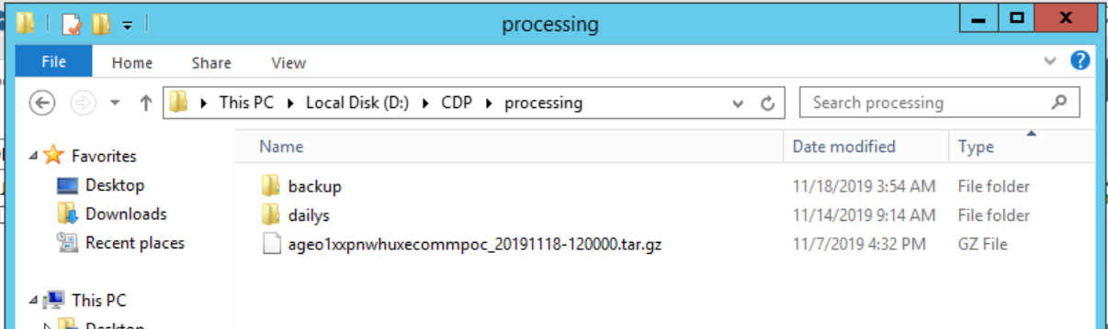

Step 2: Run the job

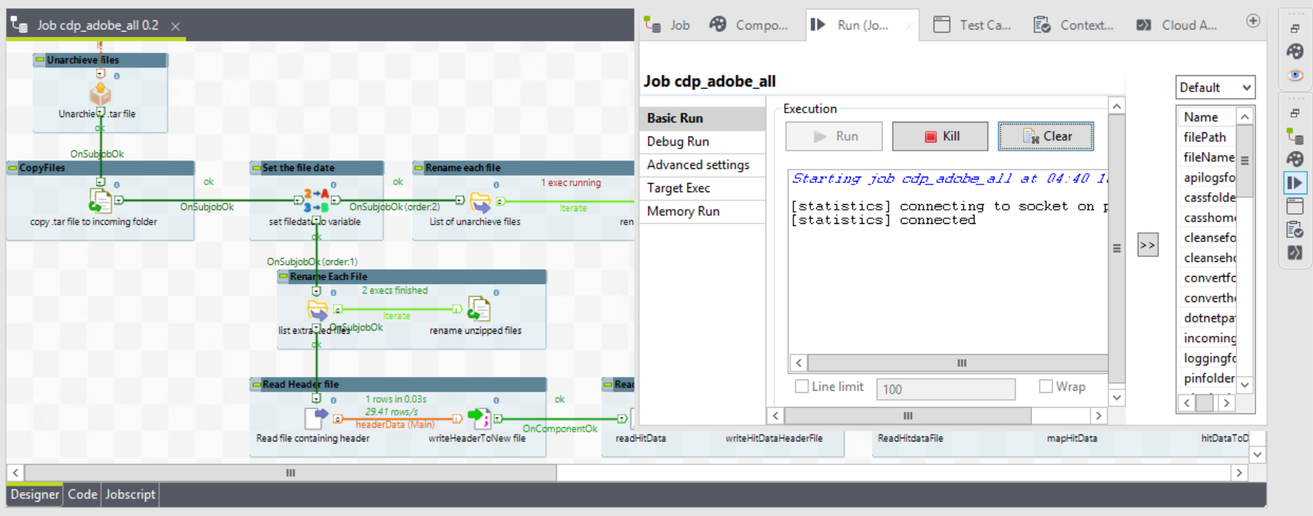

Files unzipped:

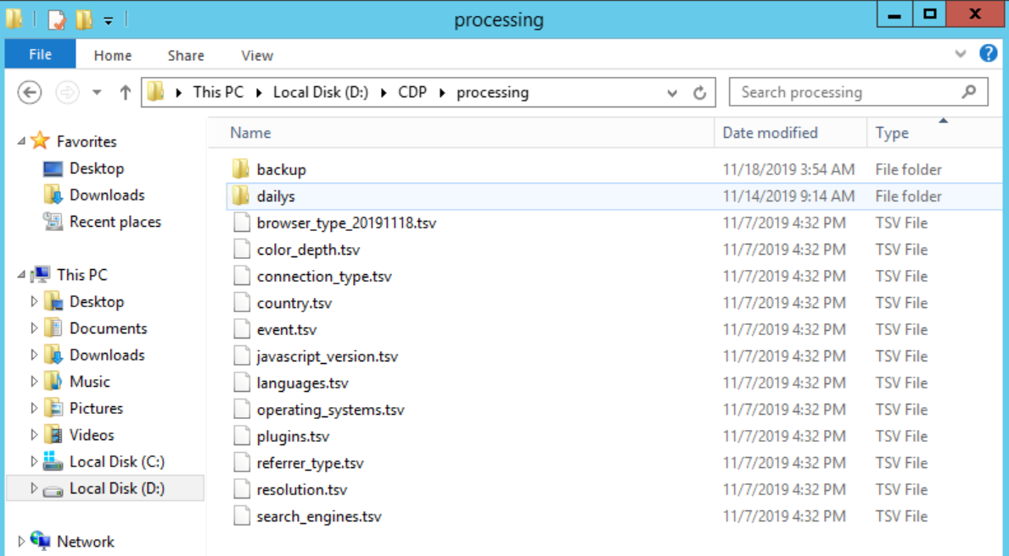

Step 3: Status of Job (RUN_LOG)

**Query used:**

*USE [CD_ADMIN]*

*GO*

*DECLARE @RUNID NVARCHAR(250) = '053de48d-3031-4a1d-ac6c-a5019db367cb'*

*SELECT * FROM [CD_ADMIN].[dbo].[RUN_LOG] WHERE RUNID = @RUNID ORDER BY 1 DESC*



Step 4: Process_log

**Query used:**

*USE [CD_ADMIN]*

*GO*

*DECLARE @RUNID NVARCHAR(250) = '053de48d-3031-4a1d-ac6c-a5019db367cb'*

*SELECT * FROM [CD_ADMIN].[dbo].[PROCESS_LOG] WHERE RUNID = @RUNID ORDER BY 1 DESC*

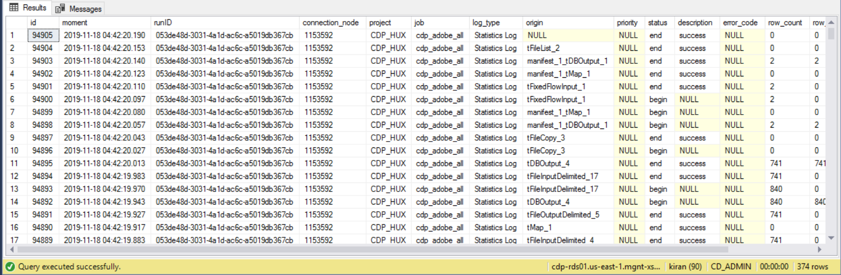

Step 5: Talend_Manifest

**Query used:**

*USE [CD_ADMIN]*

*GO*

*DECLARE @RUNID NVARCHAR(250) = '053de48d-3031-4a1d-ac6c-a5019db367cb'*

*SELECT * FROM [CD_ADMIN].[dbo].[TALEND_MANIFEST] WHERE RUNID = @RUNID ORDER BY 1 DESC*

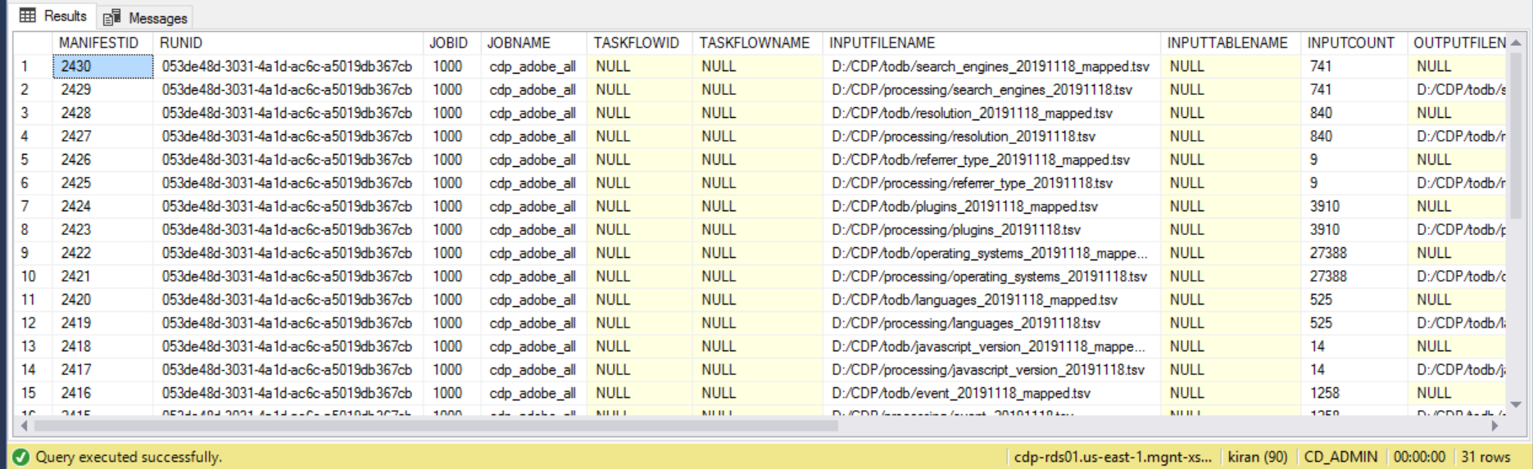

Step 6: Adobe Raw tables:

[ADOBE_BROWSER_REF]

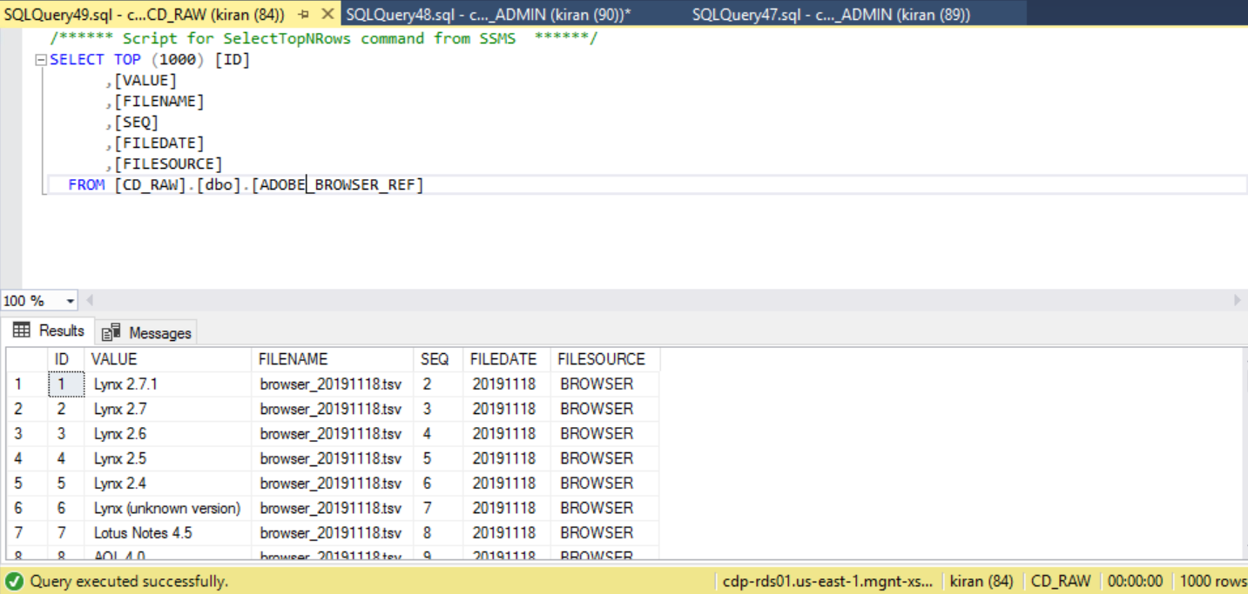

ADOBE_BROWSER_TYPE_REF

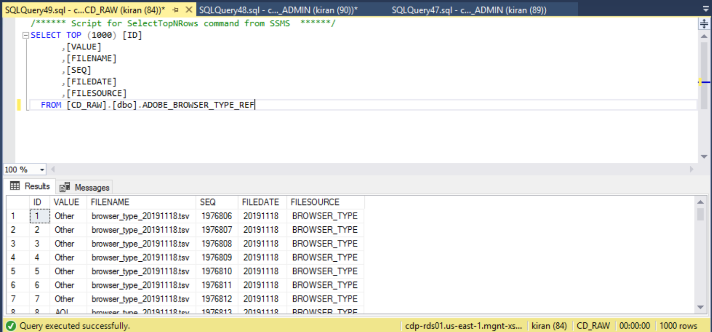

Step 7: Log files

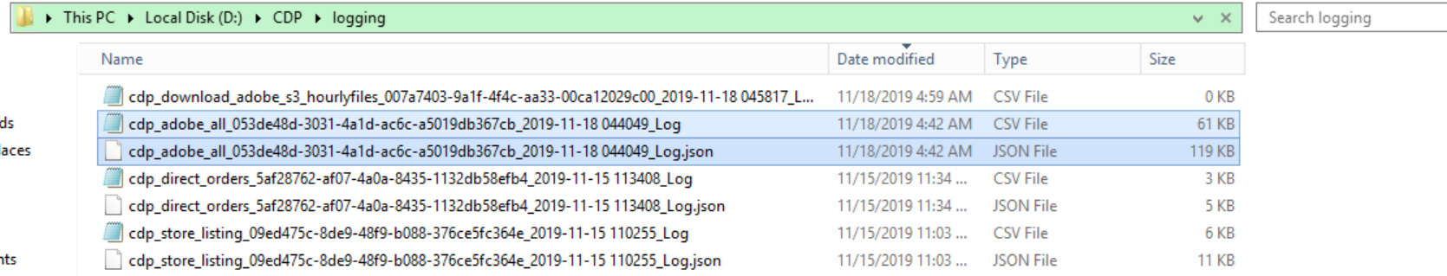

Flat File Log:

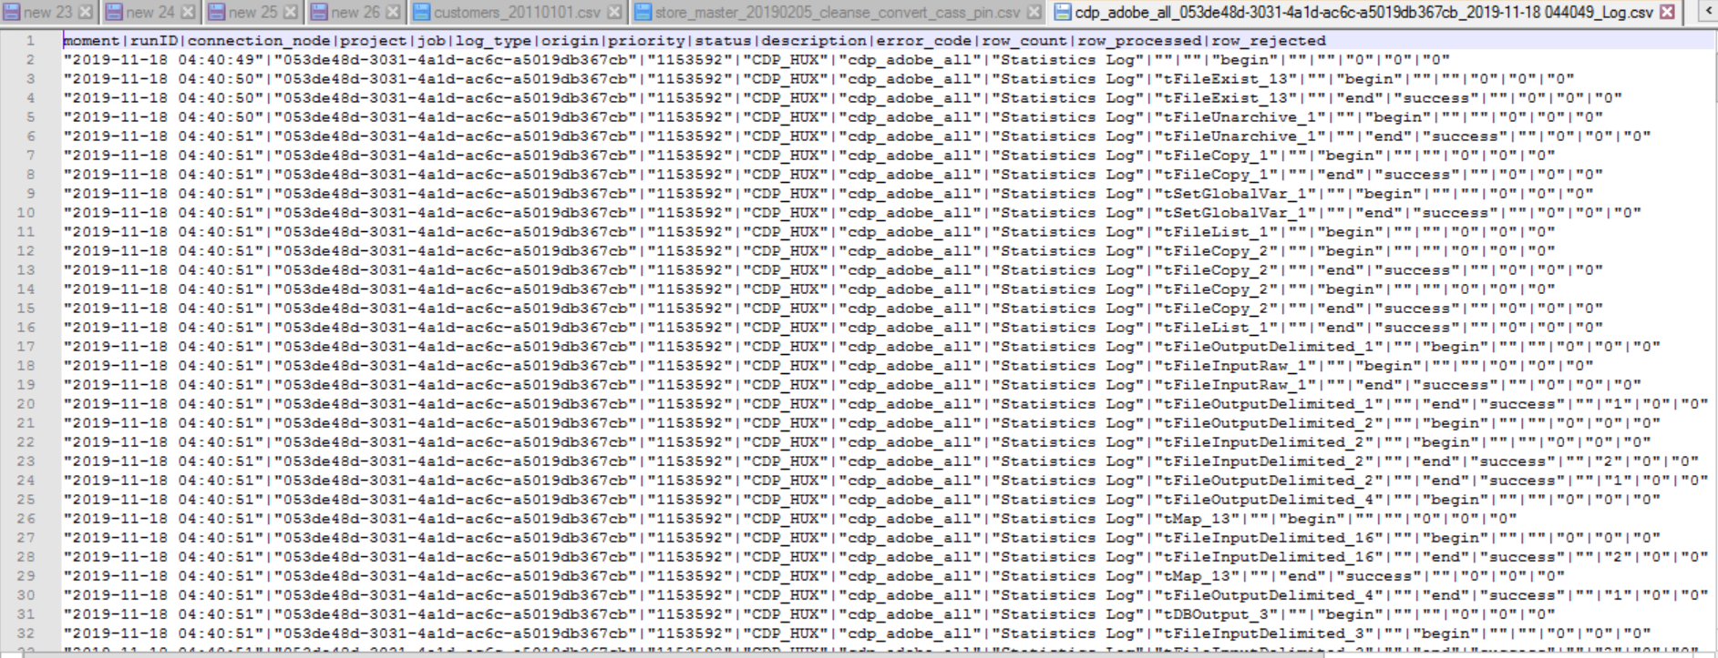

Log Json File:

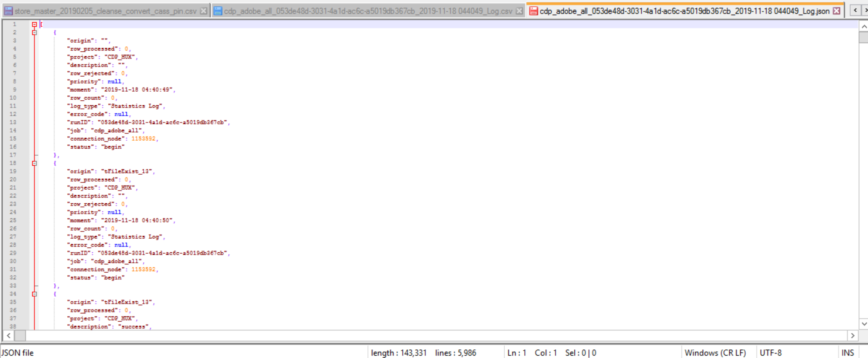

Step 8 To db folder

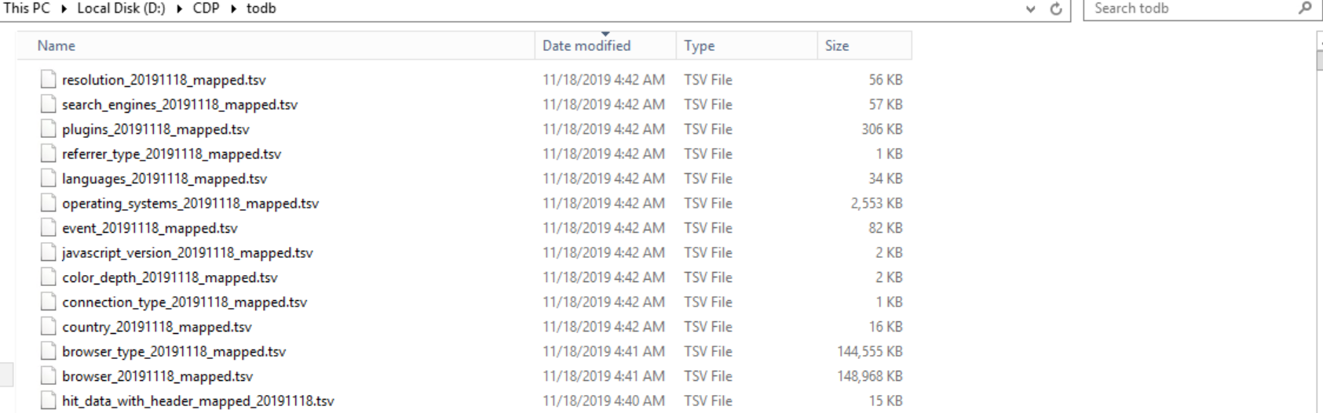

Step 9:Rejects folder

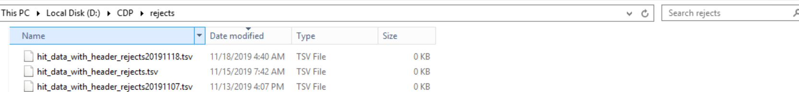

Step 10: Incoming/archive folder

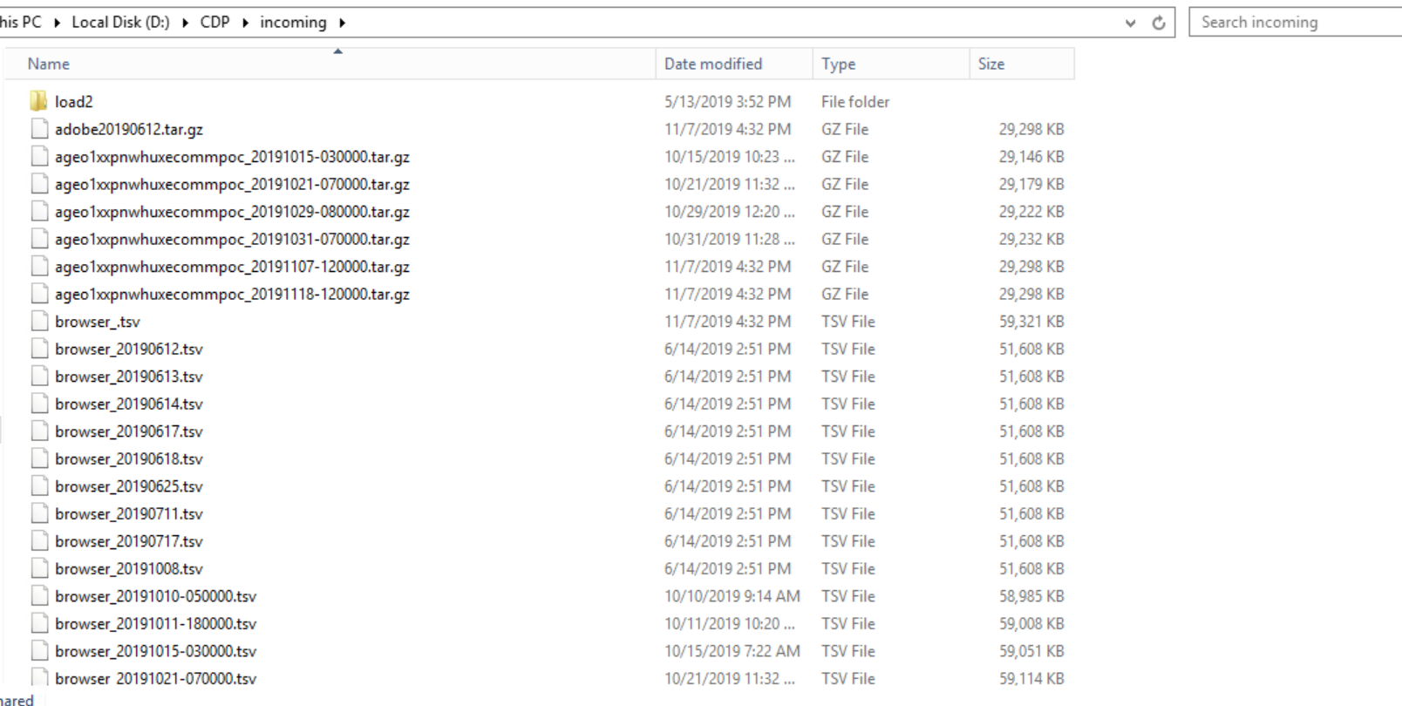

## TC case 2: File not Exists:

Step 1: File in processing folder:

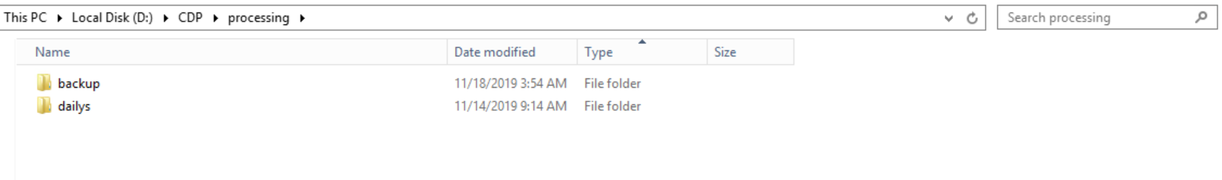

Step 2: Run the job

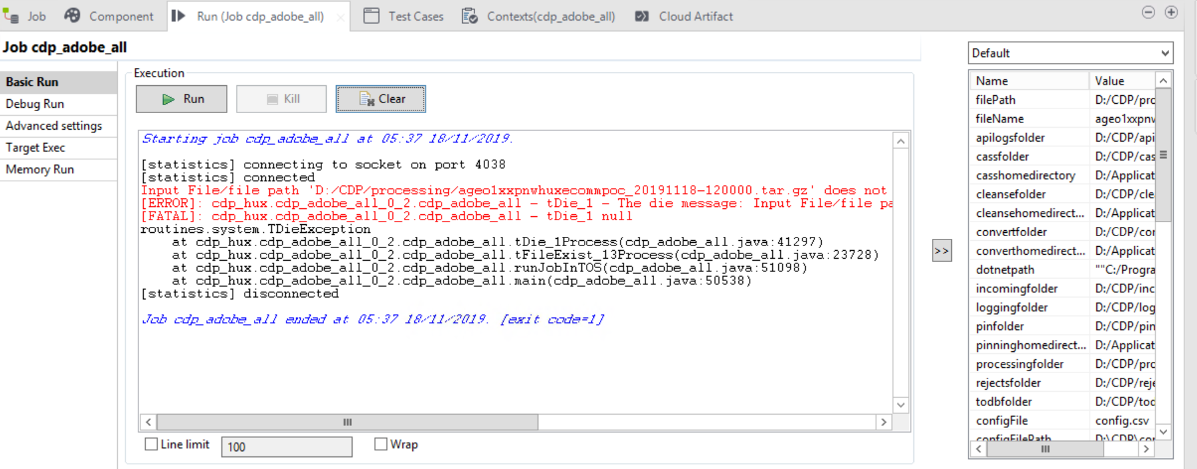

Step 3: Status of Job (RUN_LOG)

**Query used:**

*USE [CD_ADMIN]*

*GO*

*DECLARE @RUNID NVARCHAR(250) =* '2b5fb438-e796-4455-9429-77df1fb40310'

*SELECT * FROM [CD_ADMIN].[dbo].[RUN_LOG] WHERE RUNID = @RUNID ORDER BY 1 DESC*



Step 4: Process_log

**Query used:**

*USE [CD_ADMIN]*

*GO*

*DECLARE @RUNID NVARCHAR(250) =* '2b5fb438-e796-4455-9429-77df1fb40310'

*SELECT * FROM [CD_ADMIN].[dbo].[PROCESS_LOG] WHERE RUNID = @RUNID ORDER BY 1 DESC*

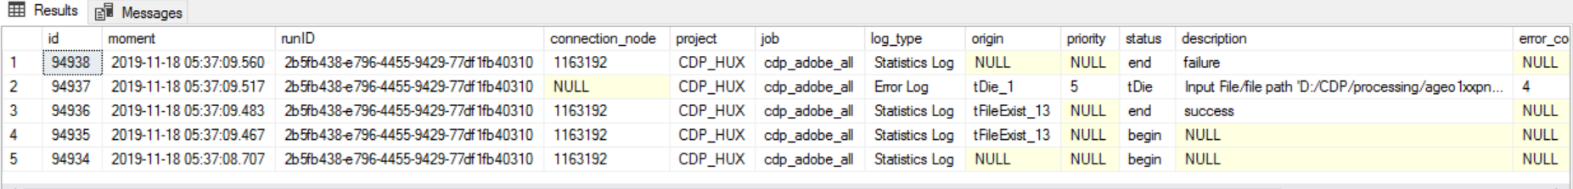

Step 5: Log files

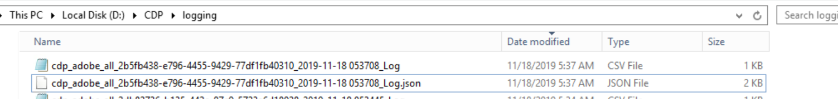

Flat File Log:



Log Json File:

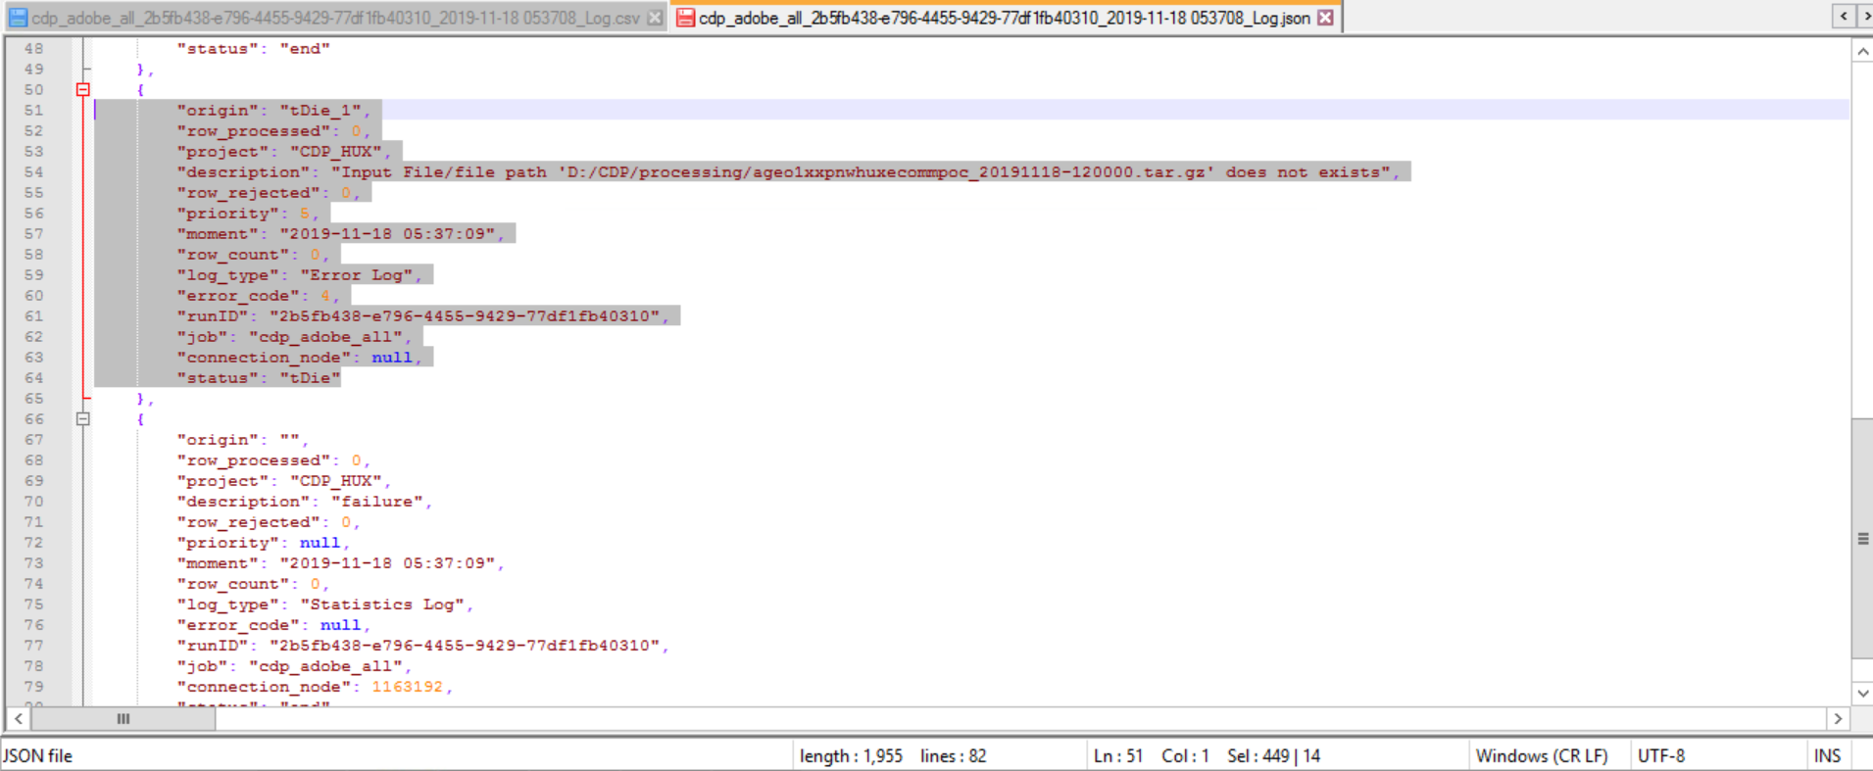

# Cdp_direct_orders:

## TC case 1: File Exists:

Step 1: File in processing folder:

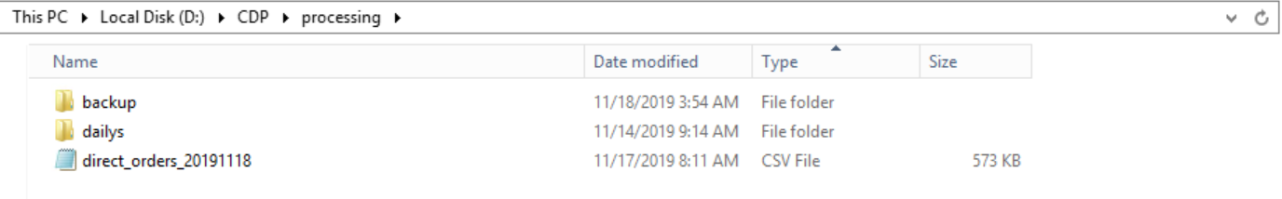

Step 2: Run the job

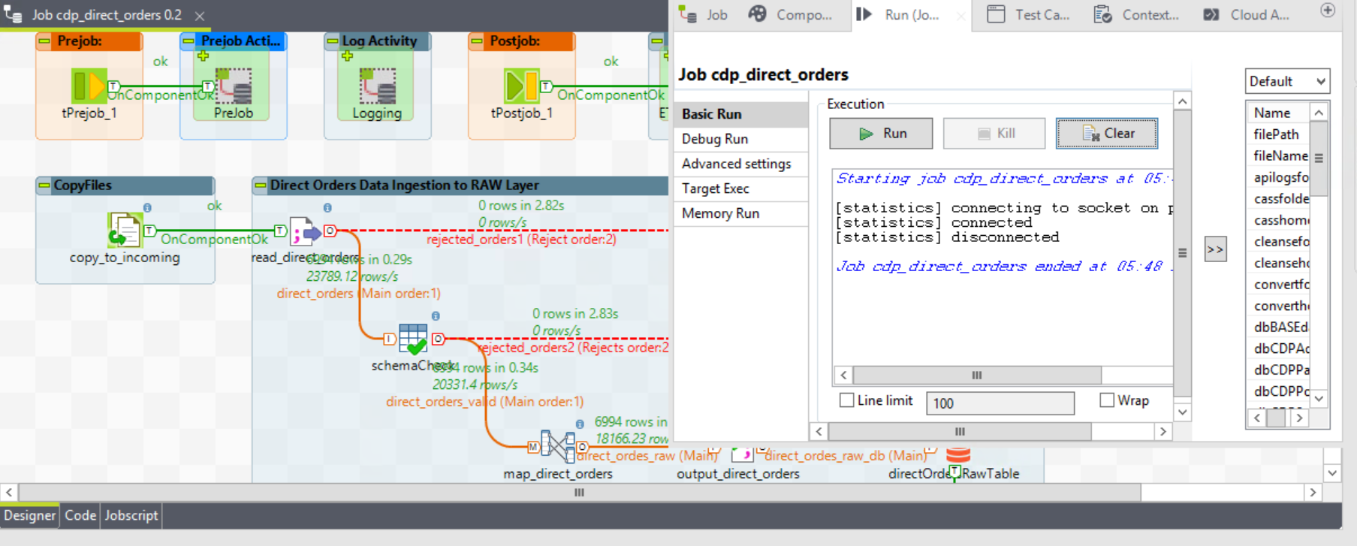

Step 3: Status of Job (RUN_LOG)

**Query used:**

*USE [CD_ADMIN]*

*GO*

*DECLARE @RUNID NVARCHAR(250) = '* *f2f48439-6987-4c8b-83db-e8d3e4cd6ad0’'*

*SELECT * FROM [CD_ADMIN].[dbo].[RUN_LOG] WHERE RUNID = @RUNID ORDER BY 1 DESC*



Step 4: Process_log

**Query used:**

*USE [CD_ADMIN]*

*GO*

*DECLARE @RUNID NVARCHAR(250) = ‘f2f48439-6987-4c8b-83db-e8d3e4cd6ad0’*

*SELECT * FROM [CD_ADMIN].[dbo].[PROCESS_LOG] WHERE RUNID = @RUNID ORDER BY 1 DESC*

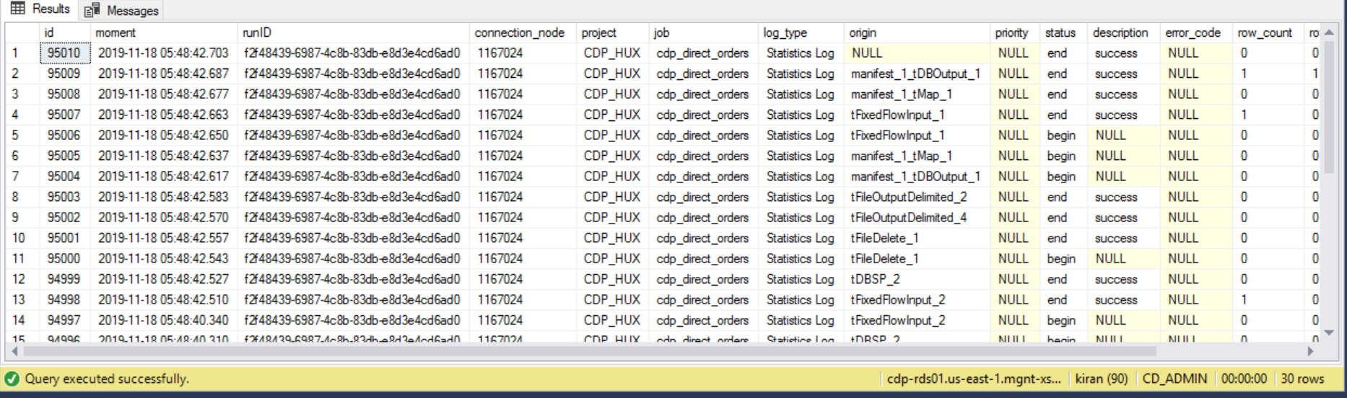

Step 5: Talend_Manifest

**Query used:**

*USE [CD_ADMIN]*

*GO*

*DECLARE @RUNID NVARCHAR(250) = ‘f2f48439-6987-4c8b-83db-e8d3e4cd6ad0'*

*SELECT * FROM [CD_ADMIN].[dbo].[TALEND_MANIFEST] WHERE RUNID = @RUNID ORDER BY 1 DESC*



Step 6: direct order Raw and LTD table:

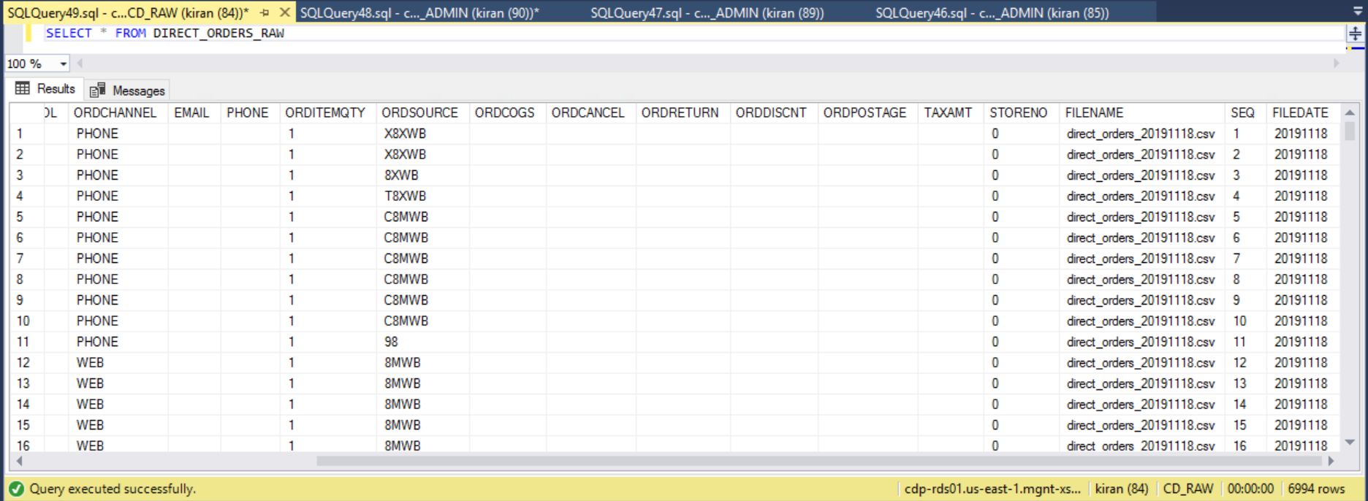

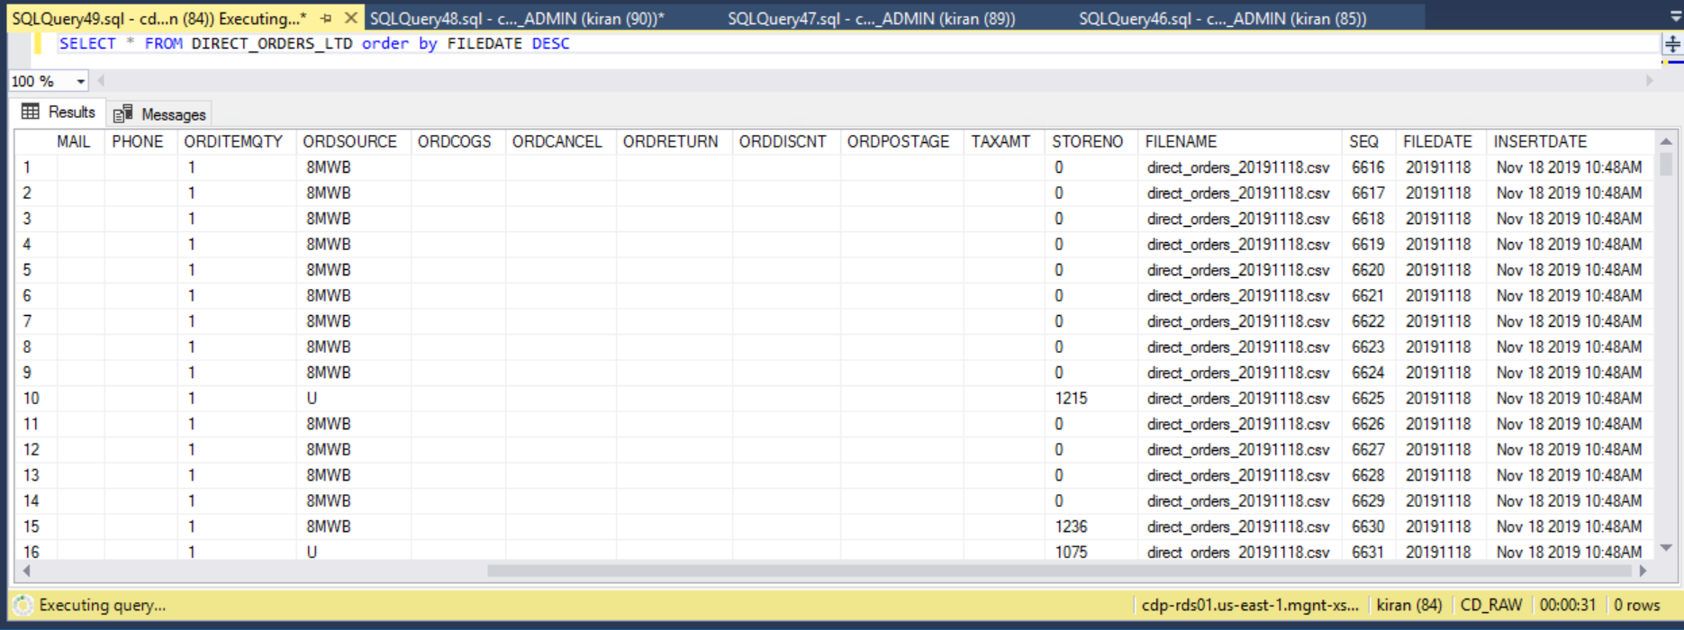

Step 7: Log files

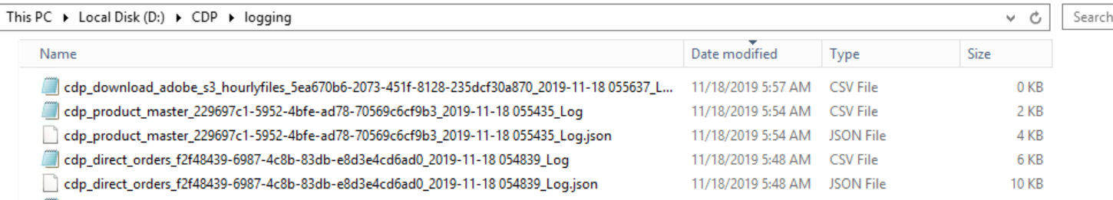

Flat File Log:

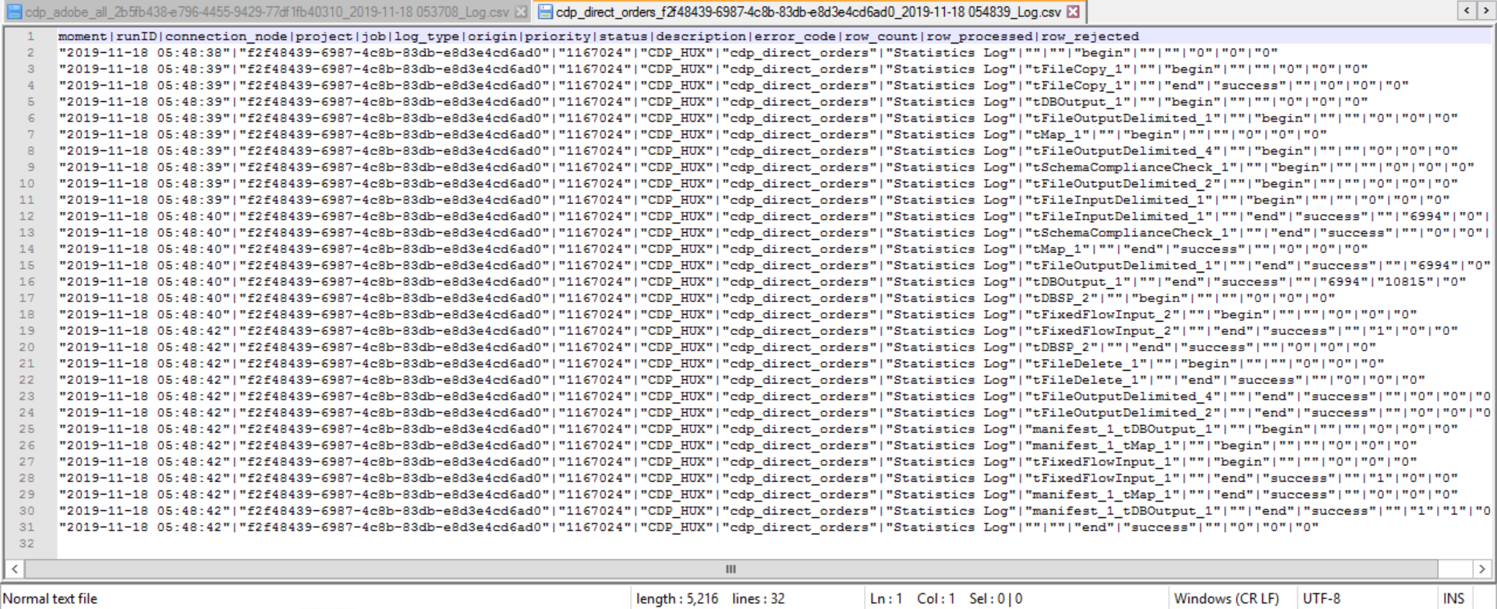

Log Json File:

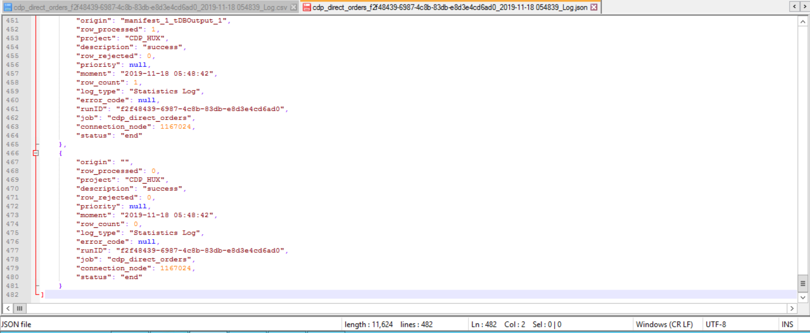

Step 8 To db folder



Step 9:Rejects folder

--no file generated as there were no rejects in file

Step 10: Incoming/archive folder

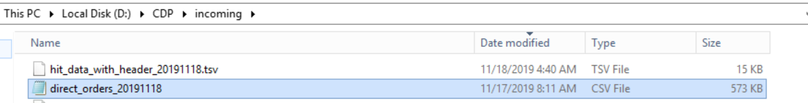

## TC case 2: File not Exists:

Step 1: File in processing folder:



Step 2: Run the job

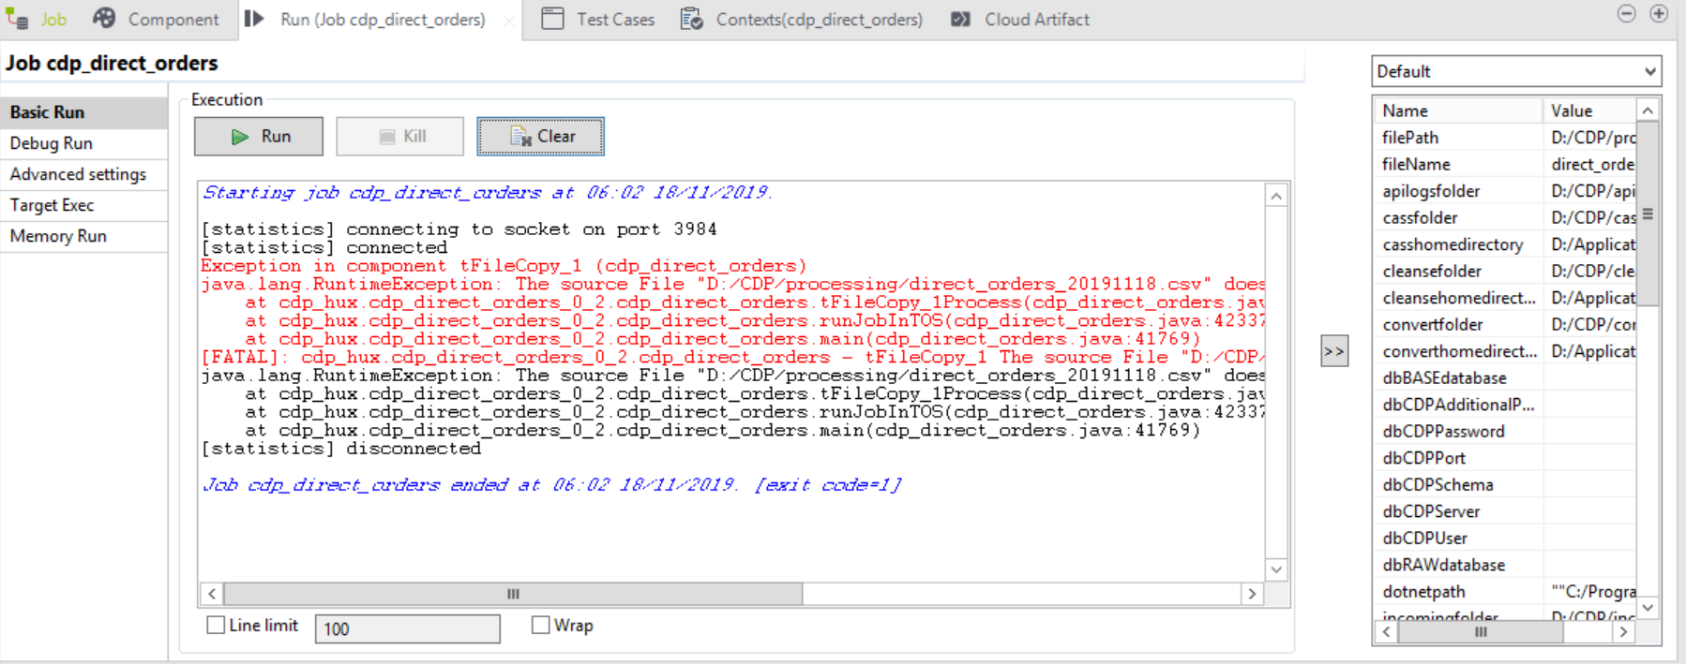

Step 3: Status of Job (RUN_LOG)

**Query used:**

*USE [CD_ADMIN]*

*GO*

*DECLARE @RUNID NVARCHAR(250) =* ‘3da8754d-d199-443d-be85-f66396476289’

*SELECT * FROM [CD_ADMIN].[dbo].[RUN_LOG] WHERE RUNID = @RUNID ORDER BY 1 DESC*



Step 4: Process_log

**Query used:**

*USE [CD_ADMIN]*

*GO*

*DECLARE @RUNID NVARCHAR(250) =* ‘3da8754d-d199-443d-be85-f66396476289’

*SELECT * FROM [CD_ADMIN].[dbo].[PROCESS_LOG] WHERE RUNID = @RUNID ORDER BY 1 DESC*

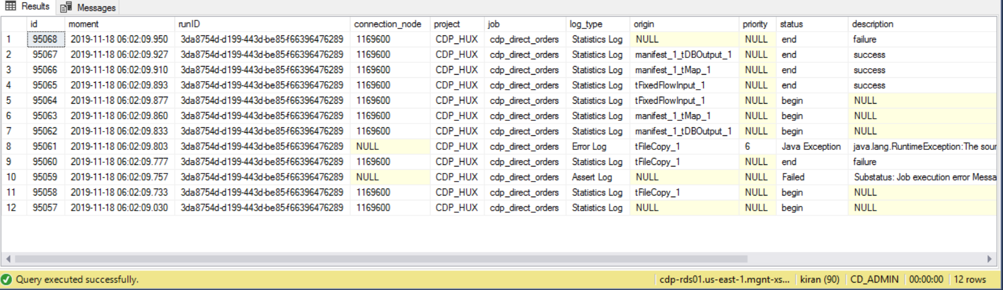

Step 5: Log files

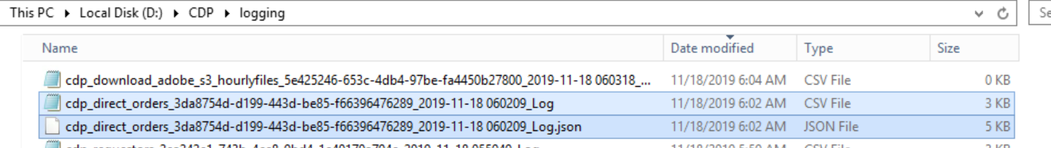

Flat File Log:

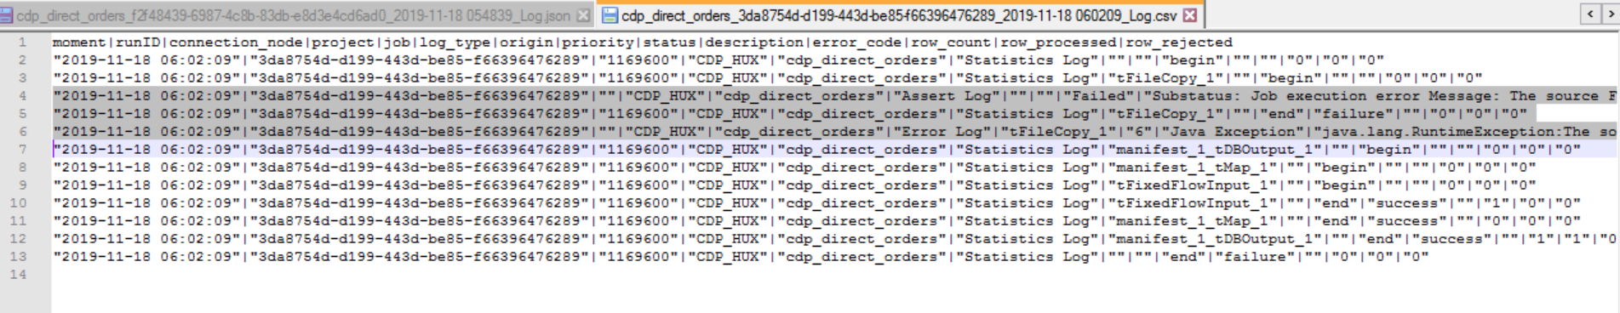

Log Json File:

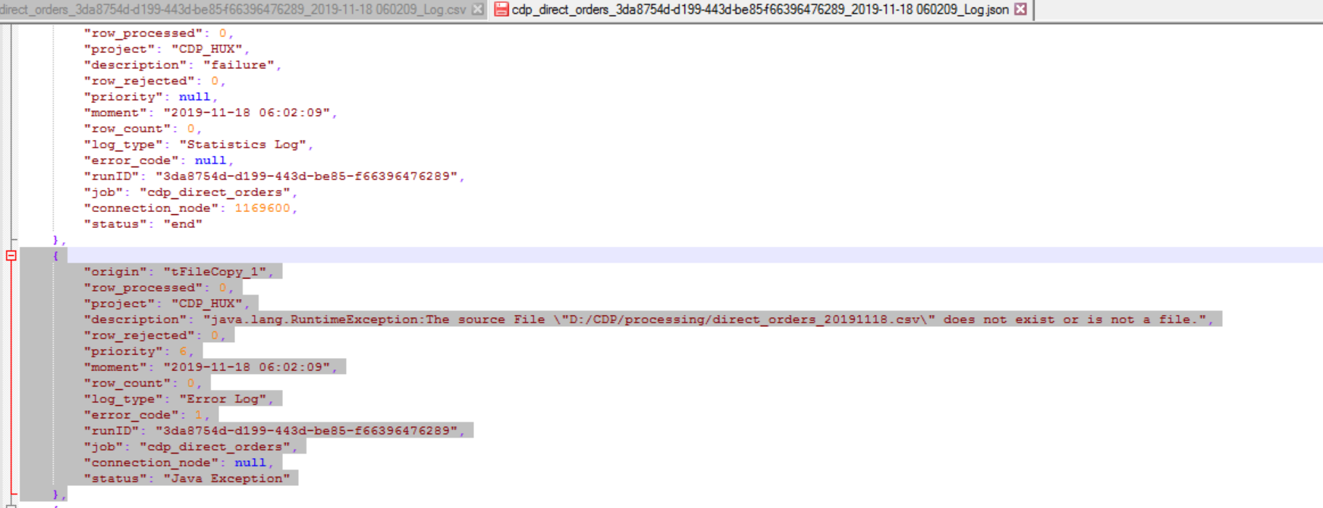

# Cdp_retail_orders:

## TC case 1: File Exists:

Step 1: File in processing folder:

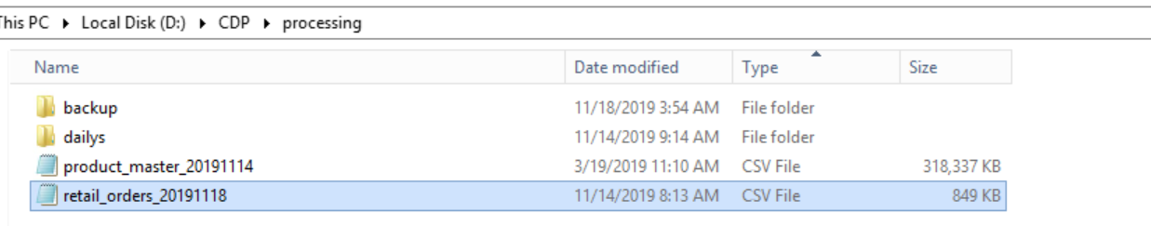

Step 2: Run the job

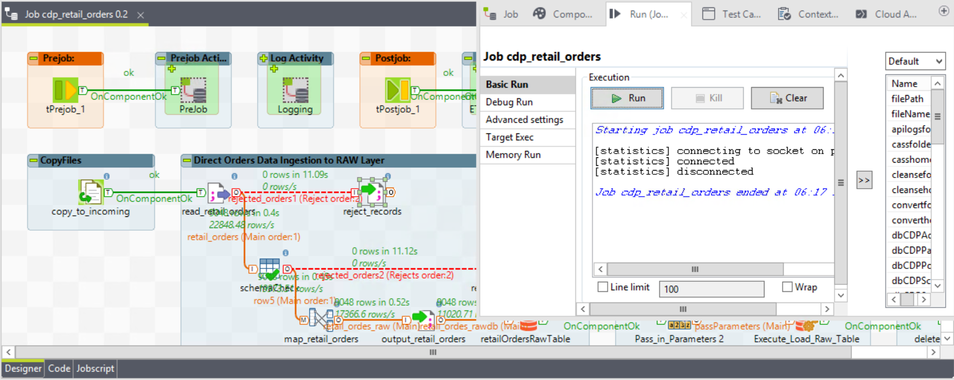

Step 3: Status of Job (RUN_LOG)

**Query used:**

*USE [CD_ADMIN]*

*GO*

*DECLARE @RUNID NVARCHAR(250) = '* *0840a585-6351-41c2-a15e-4749bef71312'*

*SELECT * FROM [CD_ADMIN].[dbo].[RUN_LOG] WHERE RUNID = @RUNID ORDER BY 1 DESC*



Step 4: Process_log

**Query used:**

*USE [CD_ADMIN]*

*GO*

*DECLARE @RUNID NVARCHAR(250) = '* *0840a585-6351-41c2-a15e-4749bef71312'*

*SELECT * FROM [CD_ADMIN].[dbo].[PROCESS_LOG] WHERE RUNID = @RUNID ORDER BY 1 DESC*

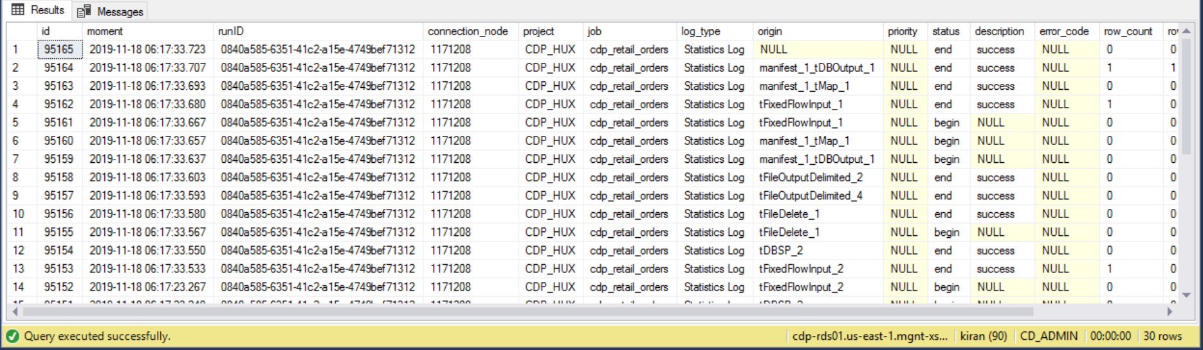

Step 5: Talend_Manifest

**Query used:**

*USE [CD_ADMIN]*

*GO*

*DECLARE @RUNID NVARCHAR(250) = '* *0840a585-6351-41c2-a15e-4749bef71312'*

*SELECT * FROM [CD_ADMIN].[dbo].[TALEND_MANIFEST] WHERE RUNID = @RUNID ORDER BY 1 DESC*



Step 6: retail order Raw and LTD table:

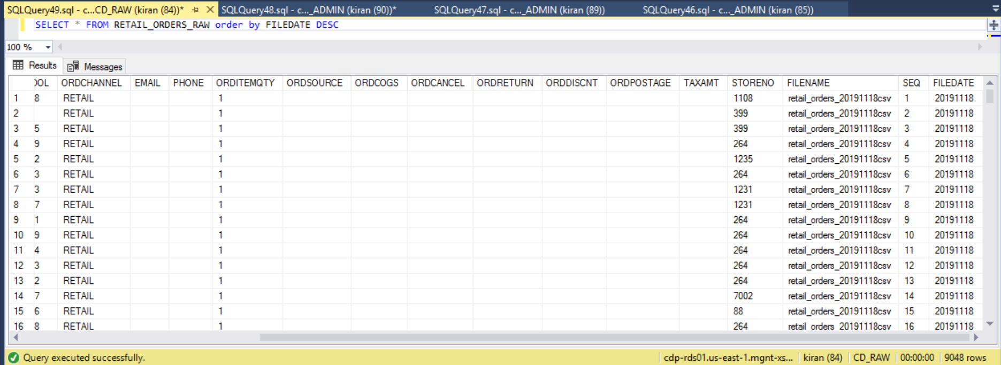

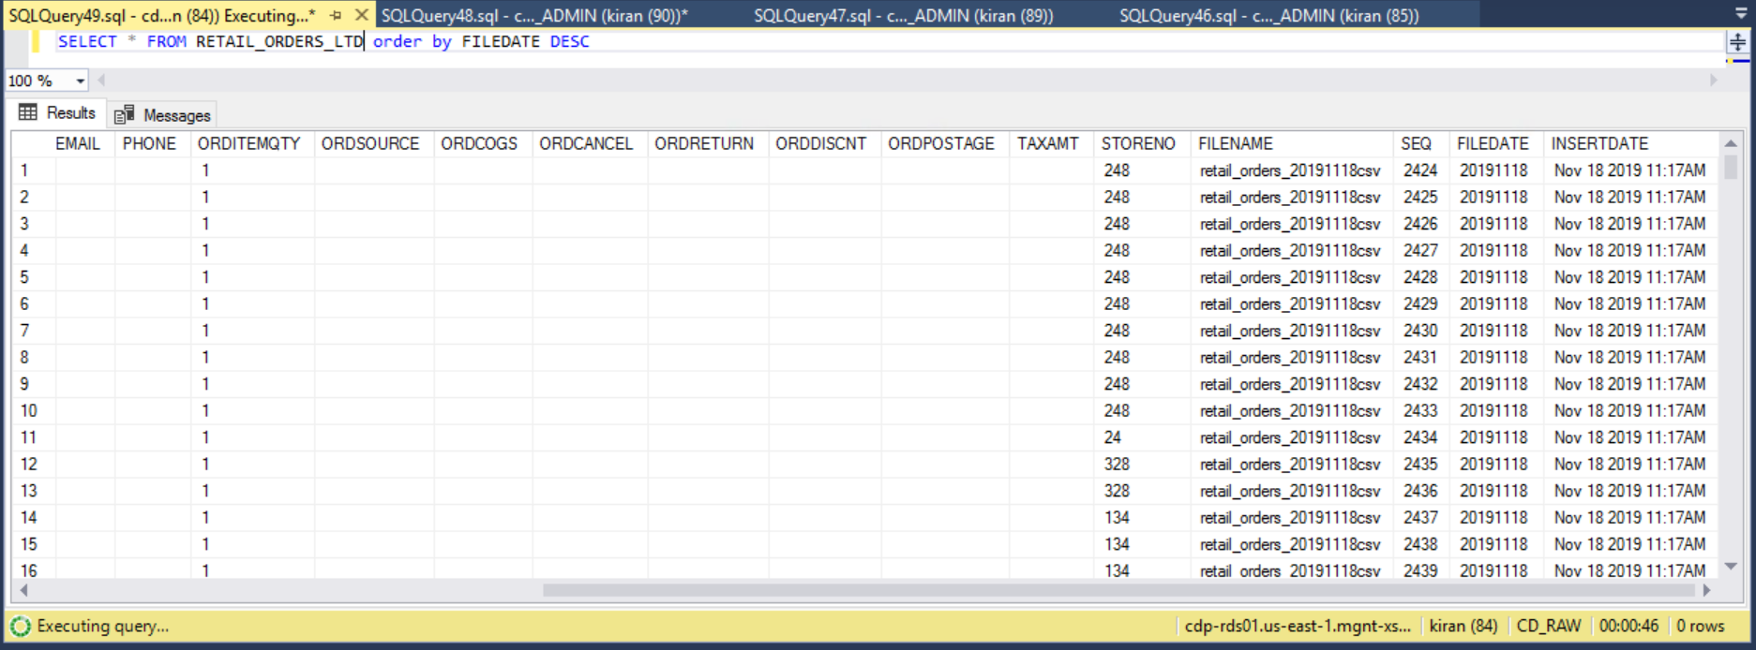

Step 7: Log files

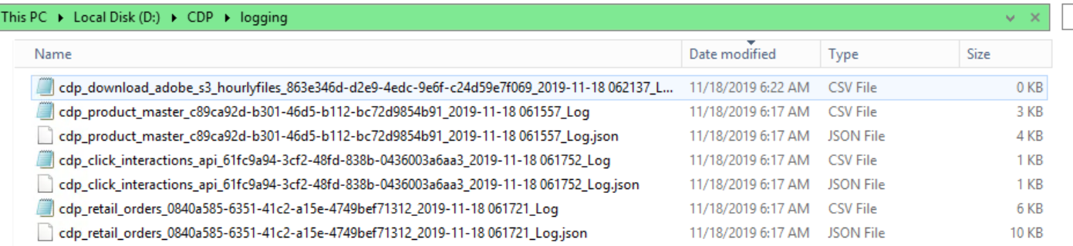

Flat File Log:

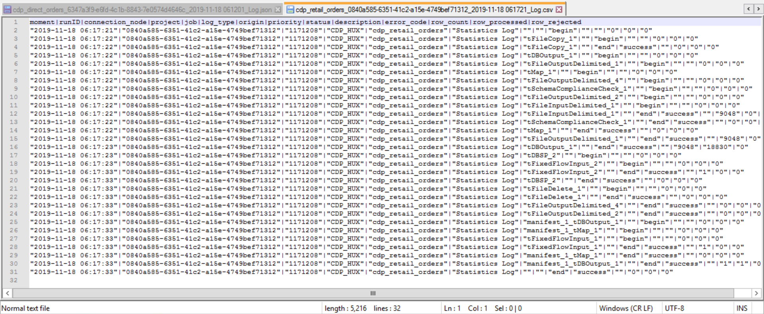

Log Json File:

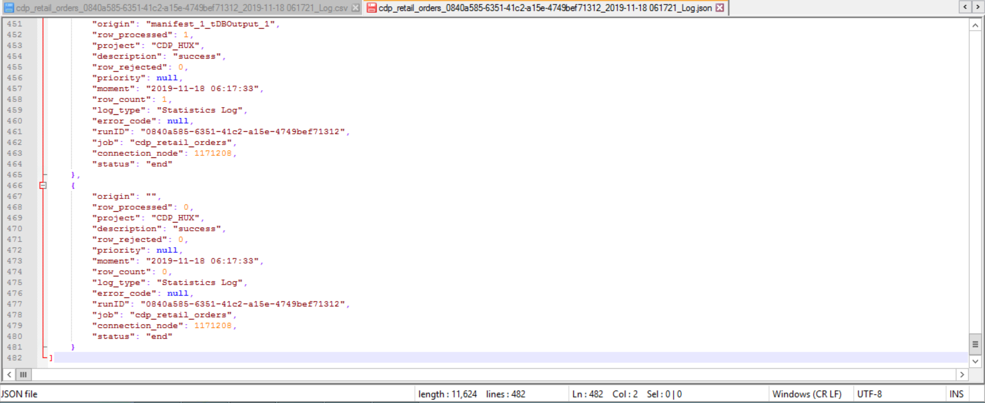

Step 8 To db folder

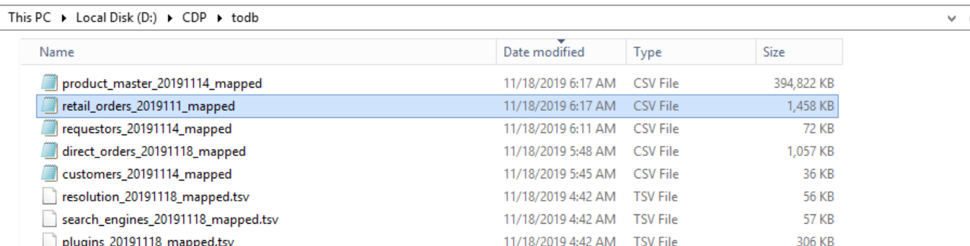

Step 9:Rejects folder

--no file generated as there were no rejects in file

Step 10: Incoming/archive folder

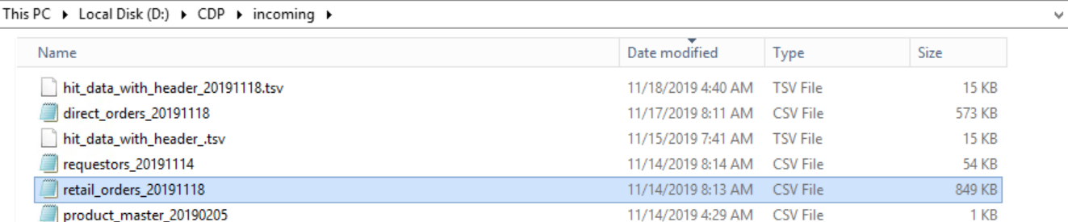

## TC case 2: File not Exists:

Step 1: File in processing folder:



Step 2: Run the job

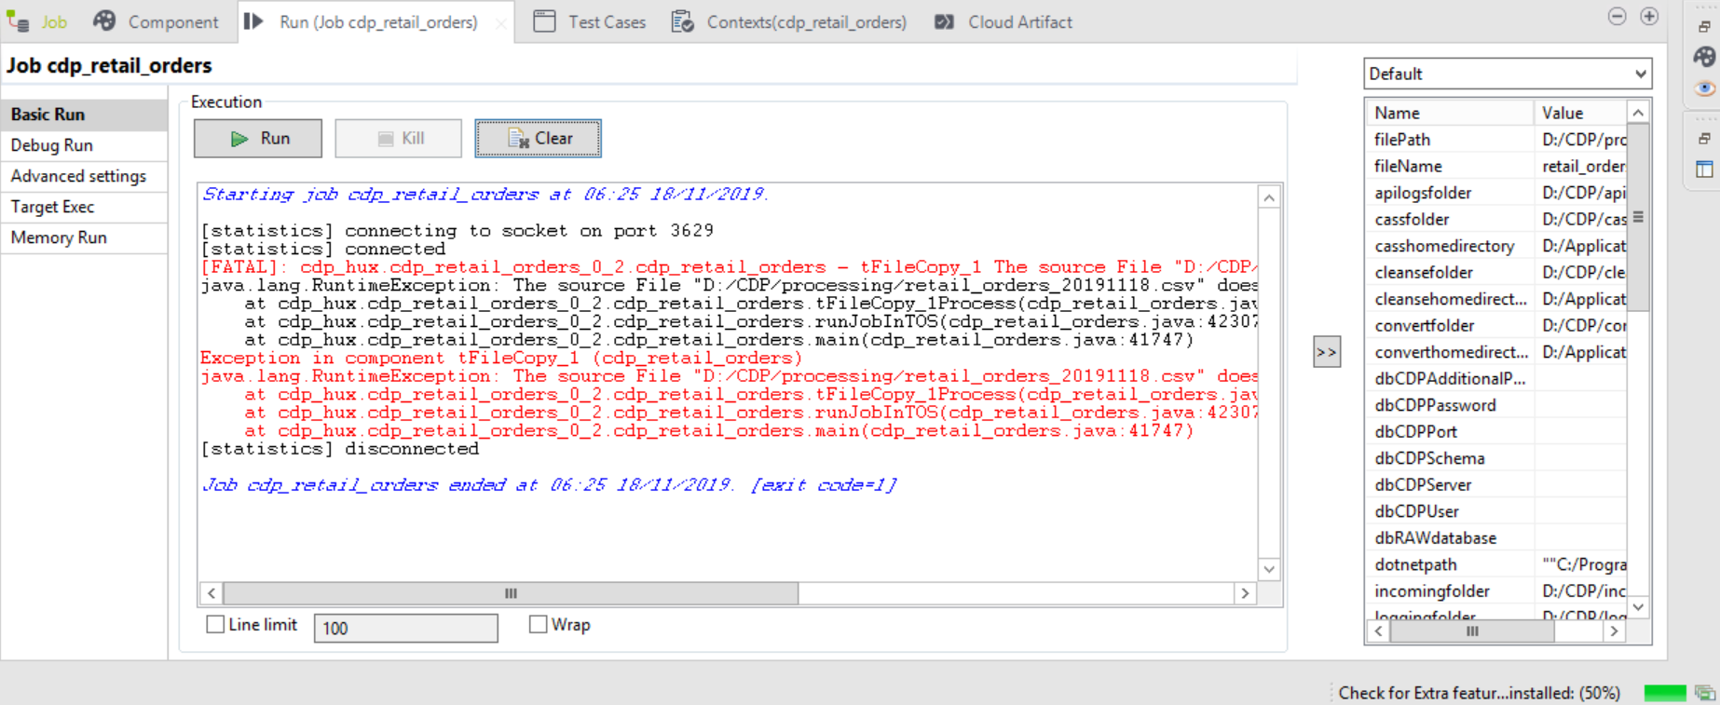

Step 3: Status of Job (RUN_LOG)

**Query used:**

*USE [CD_ADMIN]*

*GO*

*DECLARE @RUNID NVARCHAR(250) =* ‘0f54eeb7-e1ef-4f9c-9c23-6e1da9de0949’

*SELECT * FROM [CD_ADMIN].[dbo].[RUN_LOG] WHERE RUNID = @RUNID ORDER BY 1 DESC*



Step 4: Process_log

**Query used:**

*USE [CD_ADMIN]*

*GO*

*DECLARE @RUNID NVARCHAR(250) =* ‘0f54eeb7-e1ef-4f9c-9c23-6e1da9de0949’

*SELECT * FROM [CD_ADMIN].[dbo].[PROCESS_LOG] WHERE RUNID = @RUNID ORDER BY 1 DESC*

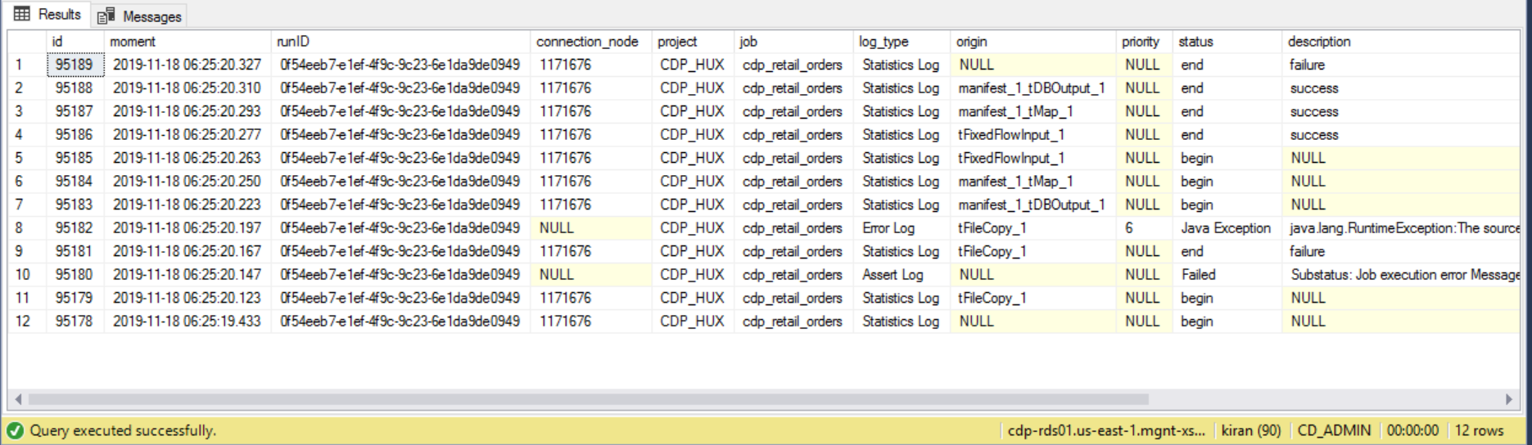

Step 5: Log files

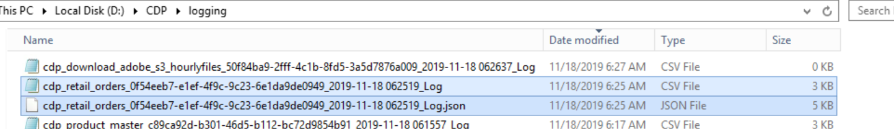

Flat File Log:

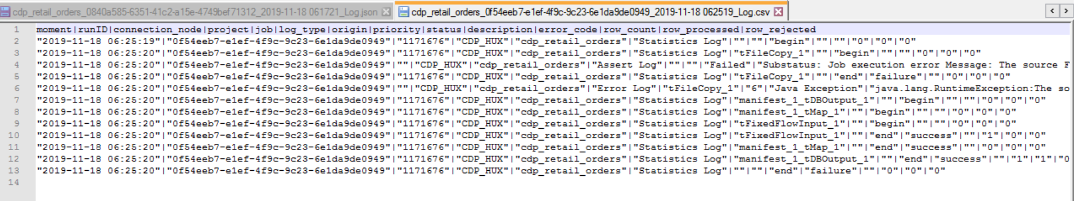

Log Json File:

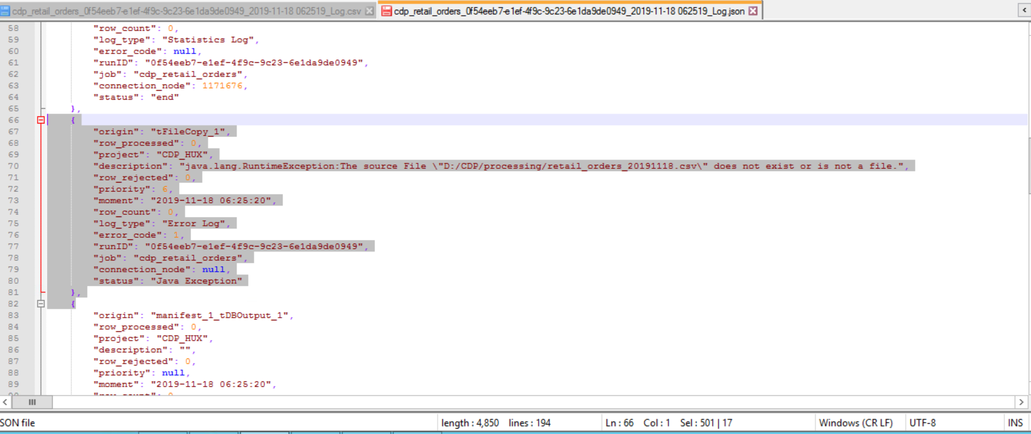

# Cdp_filewait_split:

## TC case 1: File Exists:

Step 1: Start the job

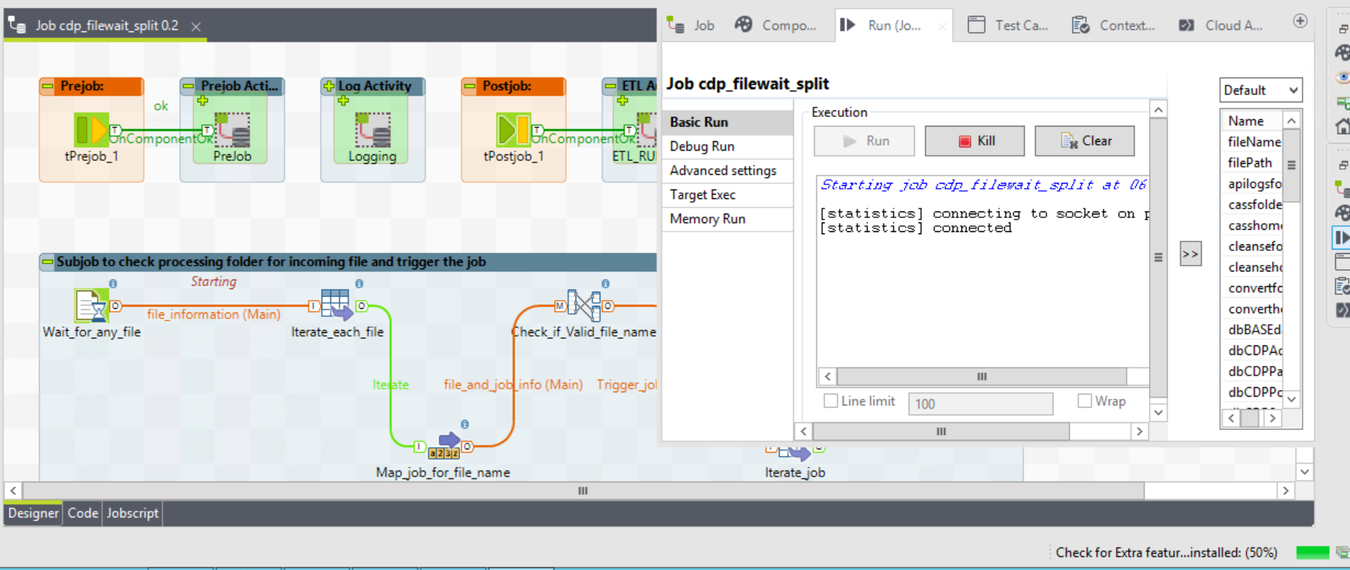

Step 2: File(s) in processing folder:

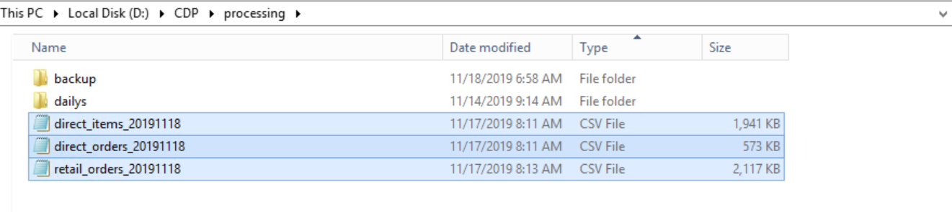

Step 3: Job Status

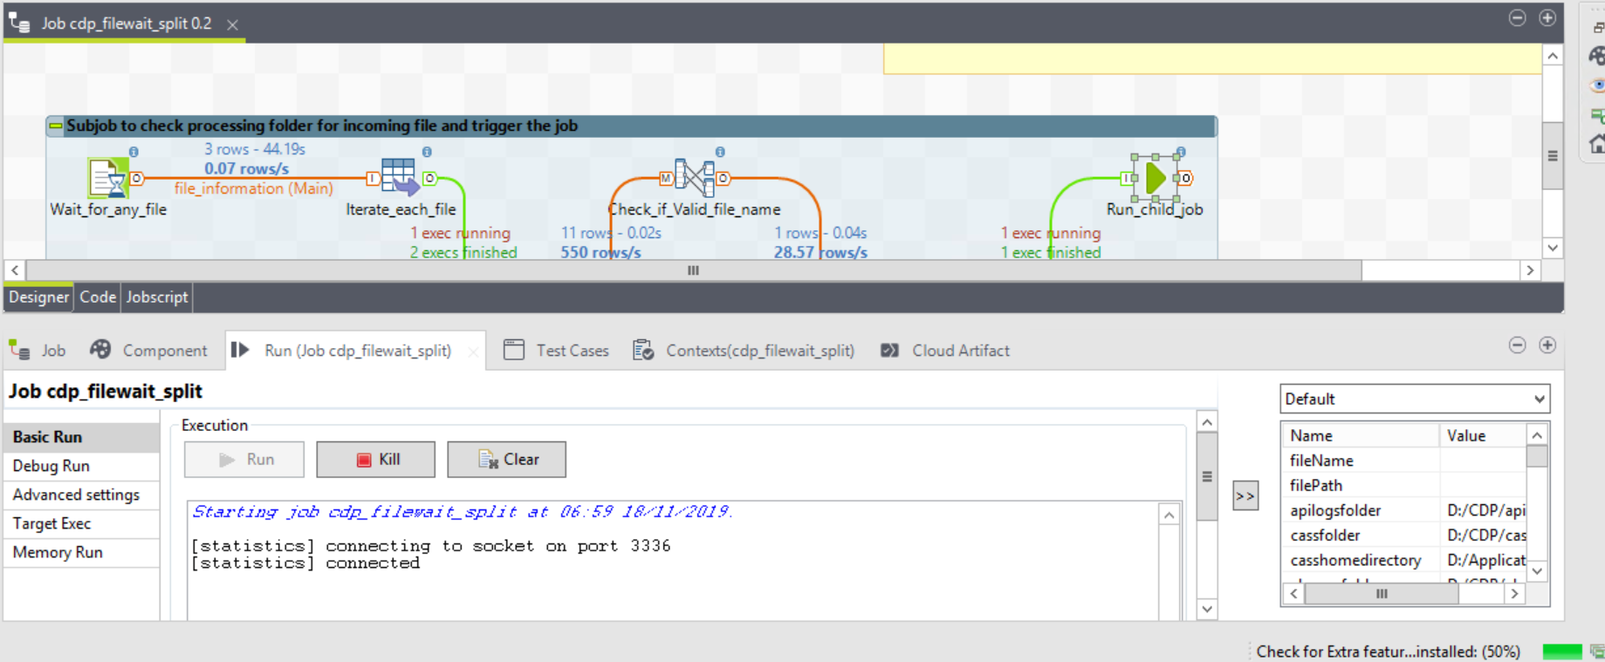

Step 4: Status of Job (RUN_LOG)

**Query used:**

*USE [CD_ADMIN]*

*GO*

*DECLARE @RUNID NVARCHAR(250) = '* *5a2f2f13-5299-413c-9c6d-0f108962aeb2'*

*SELECT * FROM [CD_ADMIN].[dbo].[RUN_LOG] WHERE RUNID = @RUNID ORDER BY 1 DESC*

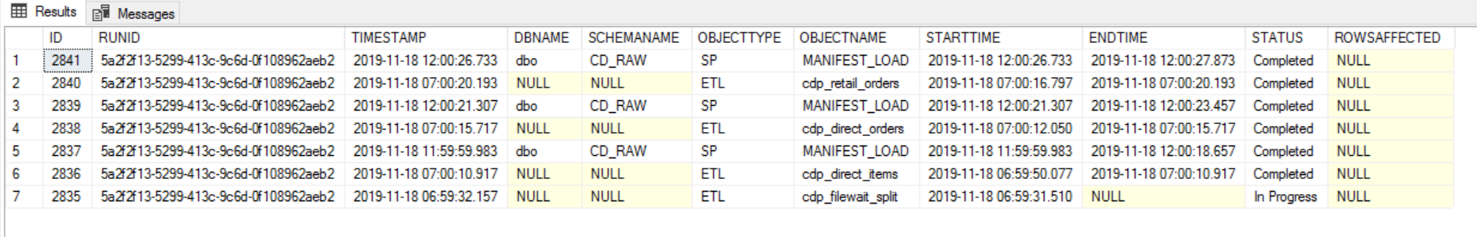

Step 4: Process_log

**Query used:**

*USE [CD_ADMIN]*

*GO*

*DECLARE @RUNID NVARCHAR(250) = '* *5a2f2f13-5299-413c-9c6d-0f108962aeb2'*

*SELECT * FROM [CD_ADMIN].[dbo].[PROCESS_LOG] WHERE RUNID = @RUNID ORDER BY 1 DESC*

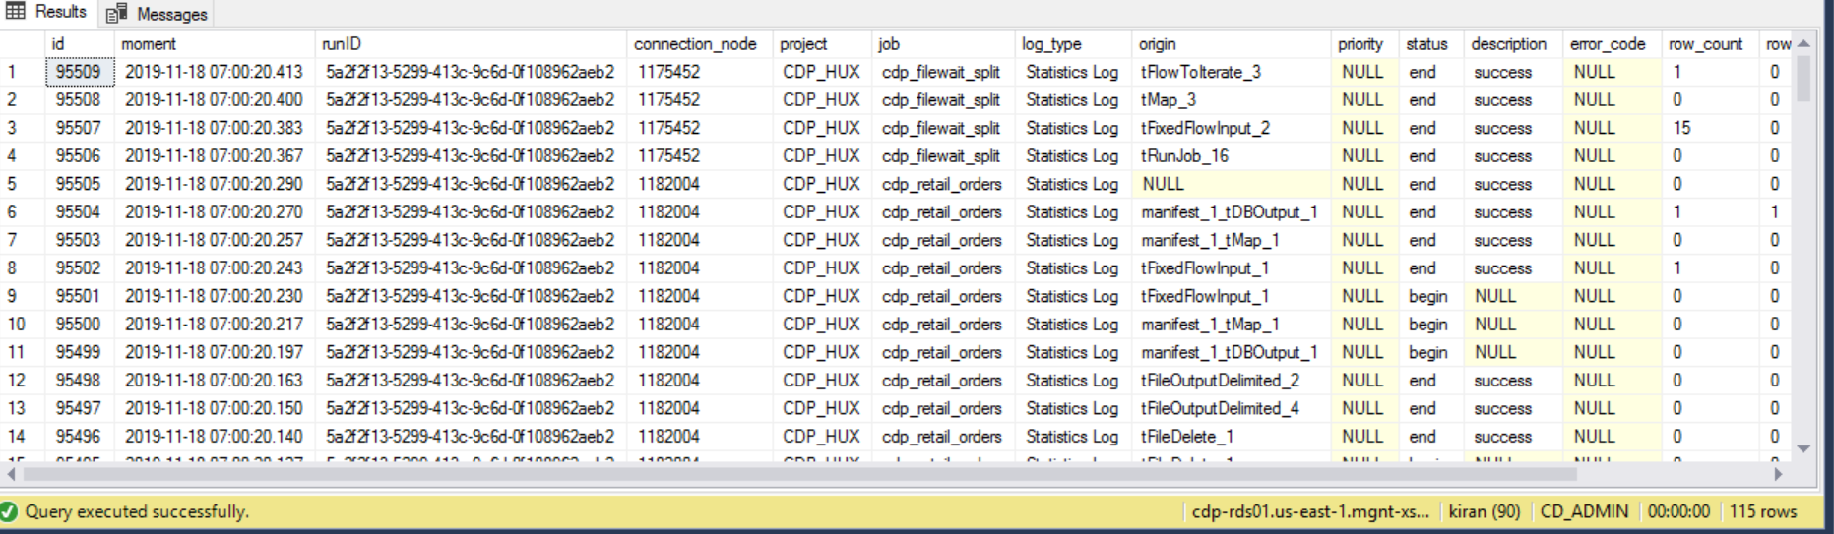

Step 5: Talend_Manifest

**Query used:**

*USE [CD_ADMIN]*

*GO*

*DECLARE @RUNID NVARCHAR(250) = '* *5a2f2f13-5299-413c-9c6d-0f108962aeb2'*

*SELECT * FROM [CD_ADMIN].[dbo].[TALEND_MANIFEST] WHERE RUNID = @RUNID ORDER BY 1 DESC*



Step 6: retail order Raw and LTD table:





Step 7: Log files

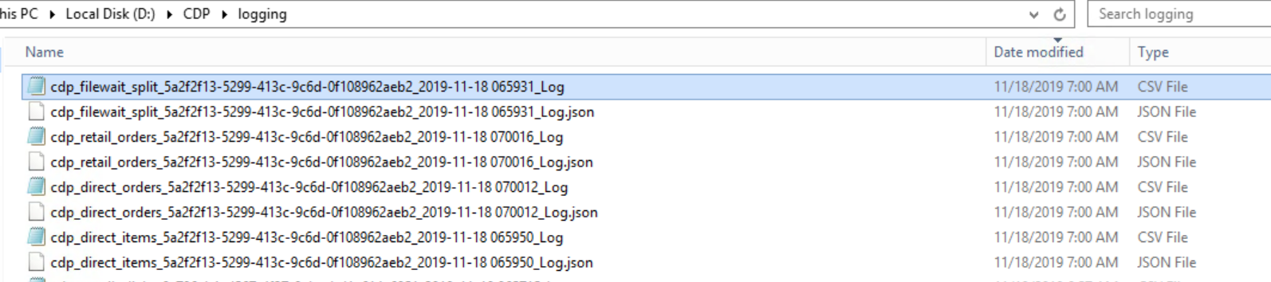

Flat File Log:

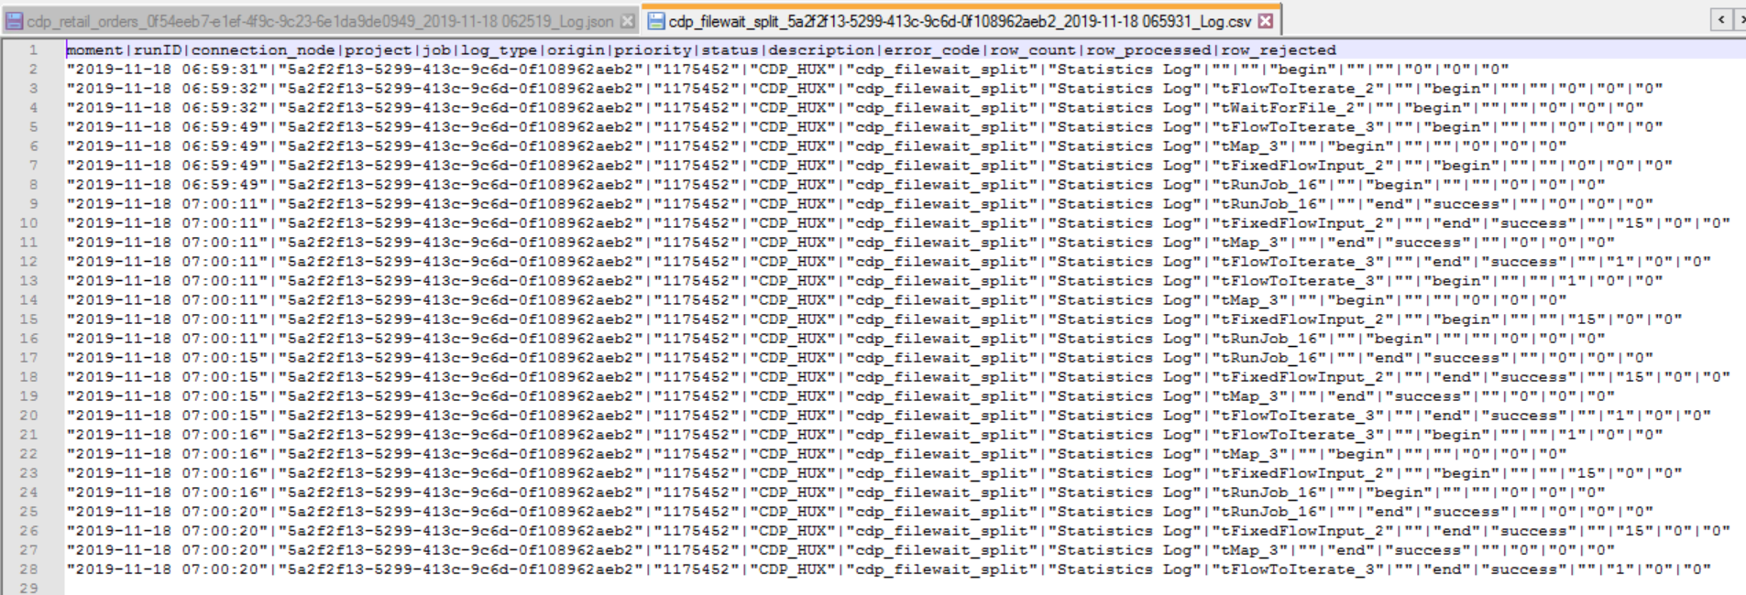

Log Json File:

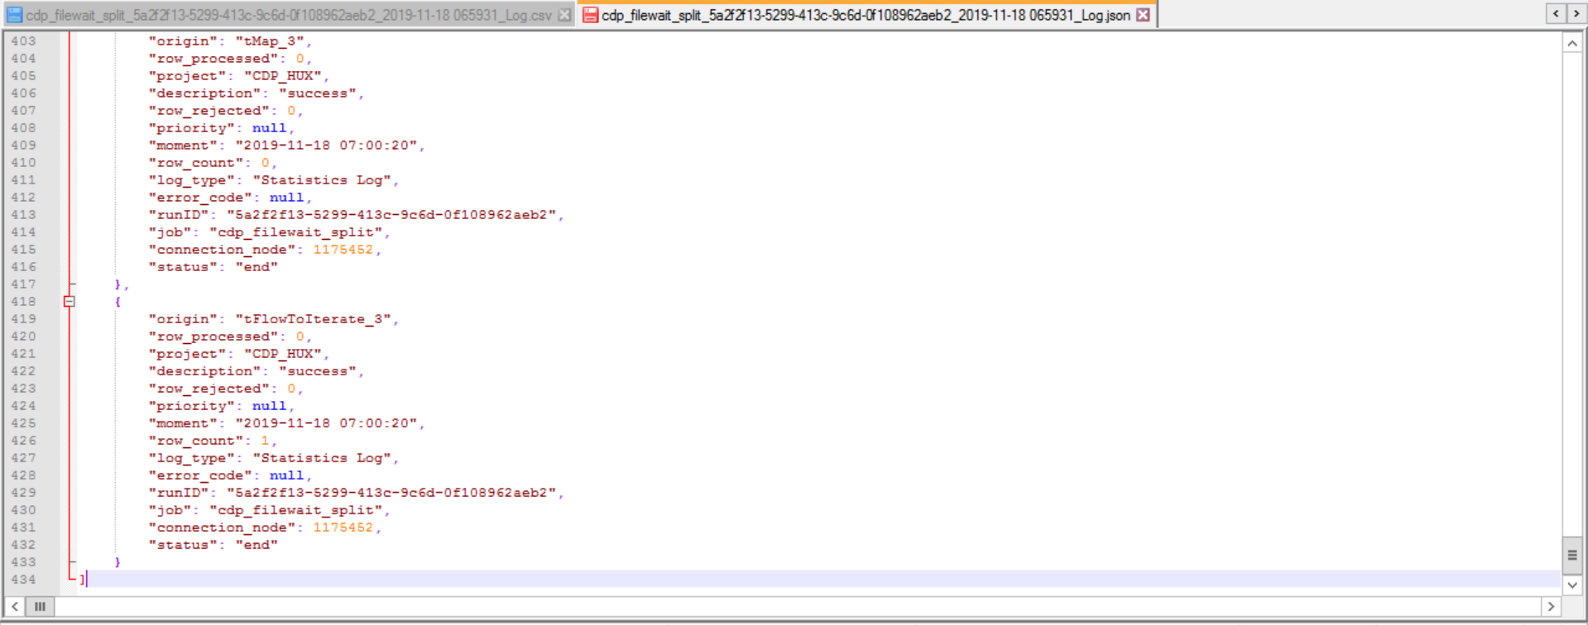

Step 8 To db folder

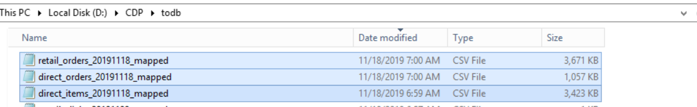

Step 9:Rejects folder

--no file generated as there were no rejects in file

Step 10: Incoming/archive folder

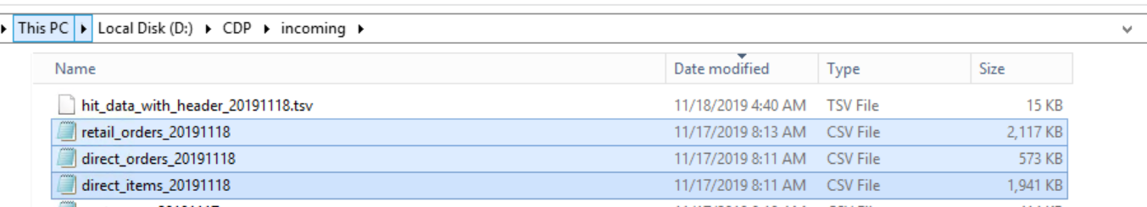

## TC case 2: File not Exists:

Not applicable, as this job runs as service.